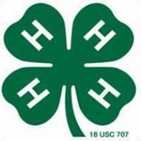
Application, Resume, Interview (ARI)

Position Overview

Corner Lot Chevrolet Inc. Position: Automotive Service Tech Assistant

Corner Lot Chevrolet is seeking a part-time employee to join the service team! Position will assist in checking and gathering supplies for required service, washing and detailing vehicles, cleaning and organizing the service department, and assisting technicians with auto repair. The individual must have an interest in vehicles, a willingness to learn, and a strong work ethic.

Essential Job Functions
- Check and gather supplies
- Wash and detail vehicles
- Assist technicians
- Maintain and safe and clean work environment
- Follow all safety rules; written and unwritten

Other Necessary Skills
- Promote a positive working environment
- Be dependable
- Arrive on time and be ready to work
- Good communication skills
- Be professional when dealing with coworkers and clients

Eligibility: 4-H Senior level
Submit: Cover letter, resume for this position and references

NOTE: This job description is not intended to be all-inclusive. Employee may perform other related duties as negotiated to meet the ongoing needs of the dealership.

